

**ALL BOOKINGS SUBJECT TO COVID -19 RESTRICTIONS AND REGULATIONS**

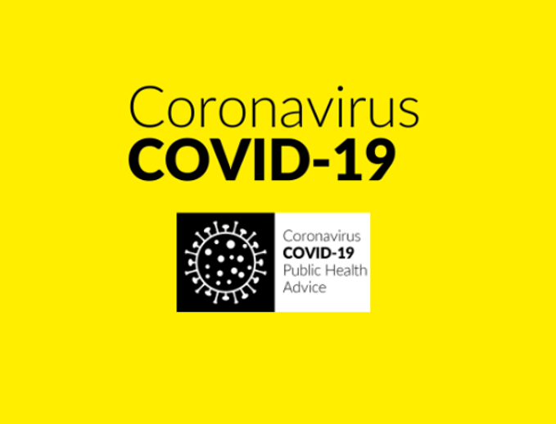

R E ST - R E C H A R G E - R E N E W

***COME TO MOUNT ST. ANNE'S***

**Rest/Holiday Opportunities**

Self-catering and full-board available on the following 2020 dates:

* + **29thSept- 2nd Oct**
  + **18th Oct- 21st Oct**
  + **4th Nov - 7th Nov**

**Arrive for lunch on the first day and leave after lunch on the last day.** €300 for full board stay. Email [secretary@mountstannes.com](mailto:secretary@mountstannes.com) for a booking form. +353(57)8626153